Name- Yashwant Patidar

Scholar no.- 191112243

Date: 23/08/2020

**Assignment 1**

1. Declare 6 arrays to store the scholar number, marks of four subjects and their total for a class is say 30 students.

2. Initialize each array with appropriate data.

3. Use the following operations on your data structures:

(a) List all the records on the screen

(b) Search for a record whose Roll No. is say, X

(c) Delete a record whose Roll No. is say, X

(d) Insert a new record just after the record, whose Roll No. = X

(e) Sort all the records according to the descending order of TOTAL

(f) Suppose, we want to merge the records of two classes. Obtain the merging in such a case,

Note: Carry out all the above tasks using the operations already defined for arrays.

**Assignment 2**

Print the lower right triangular upper left triangular both forms of tridiagonal matrix and any 3-d matrix in both row major order and column major order.

**Assignment 1:**

**Solution:**

#include<iostream>

usingnamespace std;

void show(inta[10])

{

for (int i = 0; i <5; i++)

{

cout <<a[i] <<" ";

}

cout << endl;

cout << endl;

}

int main()

{

int n;

int scholar_no[30];

int marks_s1[30] = {23,43,67,89,90};

int marks_s2[30] = {69,45,33,90,34};

int marks_s3[30] = {30,45,81,0,45};

int marks_s4[30] = {67,78,34,90,56};

int marks_total[30];

for (int i = 0; i <5; i++)

{

scholar_no[i] = i+1;

}

for (int i = 0; i <5; i++)

{

marks_total[i] = marks_s1[i] + marks_s2[i] + marks_s3[i] + marks_s4[i];

}

cout <<"Scholar no: ";

show(scholar_no);

cout <<"Marks in subject 1: ";

show(marks_s1);

cout <<"Marks in subject 2: ";

show(marks_s2);

cout <<"Marks in subject 3: ";

show(marks_s3);

cout <<"Marks in subject 4: ";

show(marks_s4);

cout <<"Marks in total: ";

show(marks_total);

cout <<"Whose detail you want to search ?";

int x;

cin >> x;

cout <<"Marks in 1: "<< marks_s1[x-1]<<"\nMarks in 2: "<<marks_s2[x-1]<<"\nMarks in 3: "<<marks_s3[x-1]<<"\nMarks in 4: "<<marks_s4[x-1]<<"\nTotal-Marks: "<<marks_total[x-1]<<endl;

cout <<"Whose record u want to delete?";

cin >> n;

int search;

for (int i = 0; i <5; i++)

{

if (n == i+1)

search = i;

}

while (search < 5)

{

scholar_no[search] = scholar_no[search + 1];

marks_s1[search] = marks_s1[search + 1];

marks_s2[search] = marks_s2[search + 1];

marks_s3[search] = marks_s3[search + 1];

marks_s4[search] = marks_s1[search + 1];

marks_total[search] = marks_total[search + 1];

search++;

}

scholar_no[4] = NULL;

marks_s1[4] = NULL;

marks_s2[4] = NULL;

marks_s3[4] = NULL;

marks_s4[4] = NULL;

marks_total[4] = NULL;

cout <<"Record after deletion";

for (int i = 0; i <4; i++)

{

cout <<" Marks in 1: "<< marks_s1[i] <<" Marks in 2: "<< marks_s2[i] <<" Marks in 3: "<< marks_s3[i] <<" Marks in 4: "<< marks_s4[i] <<" Total-Marks: "<< marks_total[i] << endl;

cout << endl;

}

cout <<"Insert the next record scholar number(5):";

int j;

cin >> j;

n = 4;

while (n >= j)

{

scholar_no[n] = scholar_no[n - 1];

marks_s1[n] = marks_s1[n - 1];

marks_s2[n] = marks_s2[n - 1];

marks_s3[n] = marks_s3[n - 1];

marks_s4[n] = marks_s4[n - 1];

n--;

}

scholar_no[j-1] = j;

cout <<"\nenter marks ";

cin >> marks_s1[j-1];

cin >> marks_s2[j-1];

cin >> marks_s3[j-1];

cin >> marks_s4[j-1];

marks_total[j-1] = marks_s1[j-1 ] + marks_s2[j-1 ] + marks_s3[j-1] + marks_s4[j-1];

for (int i = 0; i <5; i++)

cout << scholar_no[i] <<"-"<< marks_s1[i] <<"\t"<< marks_s2[i] <<"\t"<< marks_s3[i] <<"\t"<< marks_s4[i] <<" total-"<< marks_total[i] << endl;

int swap;

cout <<"\n sorting the record in descending order\n";

for (int i = 0; i <5; i++)

{

for (int k = i+1; k <5; k++)

{

if (marks_total[i] <= marks_total[k])

{

swap = marks_total[i];

marks_total[i] = marks_total[k];

marks_total[k] = swap;

swap = marks_s4[i];

marks_s4[i] = marks_total[k];

marks_total[k] = swap;

swap = marks_s3[i];

marks_s3[i] = marks_s3[k];

marks_s3[k] = swap;

swap = marks_s2[i];

marks_s2[i] = marks_s2[k];

marks_s2[k] = swap;

swap = marks_s2[i];

marks_s1[i] = marks_s1[k];

marks_s1[k] = swap;

swap = scholar_no[i];

scholar_no[i] = scholar_no[k];

scholar_no[k] = swap;

}

}

}

cout <<"Record after sorting"<< endl;

for (int i = 0; i < 5; i++)

{

cout <<" Marks in 1: "<< marks_s1[i] <<" Marks in 2: "<< marks_s2[i] <<" Marks in 3: "<< marks_s3[i] <<" Marks in 4: "<< marks_s4[i] <<" Total-Marks: "<< marks_total[i] << endl;

cout << endl;

}

int arr15[30],arr11[30],arr12[30],arr13[30],arr14[30],arr16[30];

int arr111[30], arr112[30], arr113[30], arr114[30], arr115[30];

cout <<"\narr15 contain scholar no. of students\n";

for (int i = 0; i < 5; i++)

arr15[i] = i;

cout <<"arr11 contain marks of subject 1\n";

for (int i = 0; i < 5; i++)

cin >> arr11[i];

cout <<"arr12 contain marks of subject 2\n";

for (int i = 0; i < 5; i++)

cin >> arr12[i];

cout <<"arr13 contain marks of subject 3\n";

for (int i = 0; i < 5; i++)

cin >> arr13[i];

cout <<"arr14 contain marks of subject 4\n";

for (int i = 0; i < 5; i++)

cin >> arr14[i];

cout <<"arr16 sum of marks of students are ";

for (int i = 0; i < 5; i++)

{

arr16[i] = arr11[i] + arr12[i] + arr13[i] + arr14[i];

cout <<"\t"<< arr16[i];

}

for (int i = 0; i < 5; i++)

{

arr111[i] = marks_s1[i];

arr111[i + 5] = arr11[i];

arr112[i] = marks_s2[i];

arr112[i + 5] = arr12[i];

arr113[i] = marks_s3[i];

arr113[i + 5] = arr13[i];

arr114[i] = marks_s4[i];

arr114[i + 5] = arr14[i];

arr115[i] = marks_total[i];

arr115[i + 5] = arr16[i];

}

cout <<"\narr111 is ";

for (int i = 0; i < 10; i++)

cout <<"\t"<< arr111[i];

cout <<"\narr112 is ";

for (int i = 0; i < 10; i++)

cout <<"\t"<< arr112[i];

cout <<"\narr113 is ";

for (int i = 0; i < 10; i++)

cout <<"\t"<< arr113[i];

cout <<"\narr114 is ";

for (int i = 0; i < 10; i++)

cout <<"\t"<< arr114[i];

cout <<"\narr115 is ";

for (int i = 0; i < 10; i++)

cout <<"\t"<< arr115[i];

return 0;

}

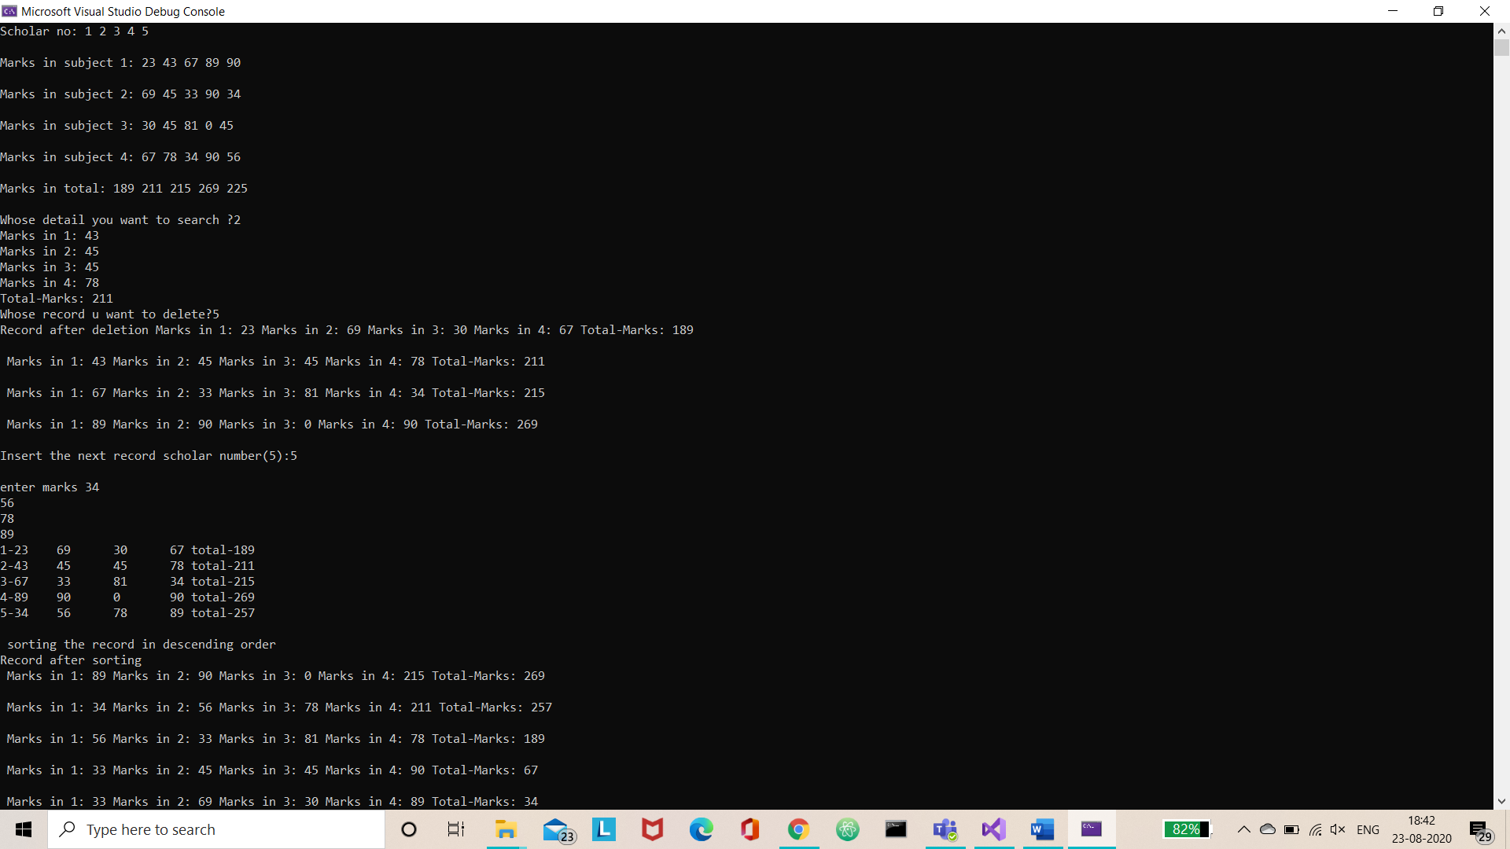

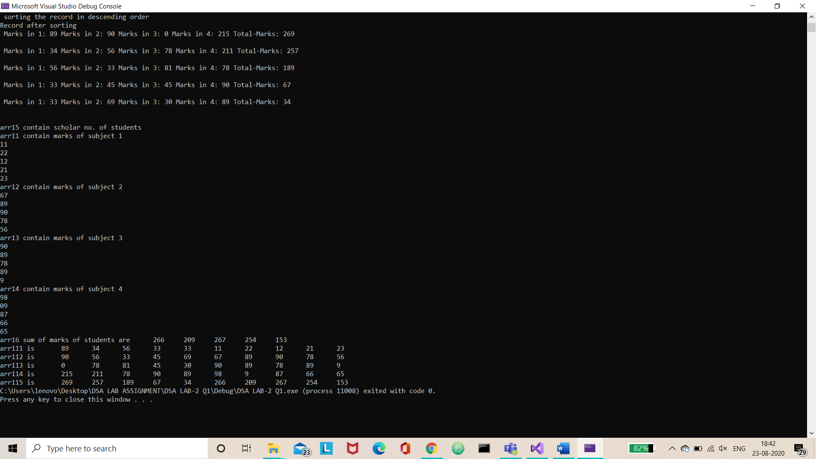

**Assignment 2:**

**Solution :**

#include<iostream>

usingnamespace std;

int main()

{

int matrix[5][5] = {

{1,2,3,4,5},

{6,7,8,9,10},

{11,12,13,14,15},

{16,17,18,19,20},

{21,22,23,24,25},

};

cout <<"matrix is: \n";

for (int i = 0; i < 5; i++)

{

for (int j = 0; j < 5; j++)

{

cout << matrix[i][j] <<"\t";

}

cout << endl;

}

cout << endl;

//lower right triangular in row major

cout <<"Lower right triangular matrix in row major order: ";

for (int i = 0; i < 5; i++)

{

for (int j = 4 - i; j < 5; j++)

{

cout << matrix[i][j] <<" ";

}

}

cout << endl;

//lower right triangular in column major

cout <<"Lower right triangular matrix in column major order: ";

for (int j = 0; j < 5; j++)

{

for (int i = 4 - j; i < 5; i++)

{

cout << matrix[i][j] <<" ";

}

}

cout << endl;

//upper left triangular in row major

cout <<"Upper left triangular matrix in row major order: ";

for (int i = 0; i < 5; i++)

{

for (int j = 0; j < (5 - i); j++)

{

cout << matrix[i][j] <<" ";

}

}

cout << endl;

//upper left triangular in column major

cout <<"Upper left triangular matrix in column major order: ";

for (int j = 0; j < 5; j++)

{

for (int i = 0; i < (5 - j); i++)

{

cout << matrix[i][j] <<" ";

}

}

cout << endl;

//tridiagonal matrix in row major

cout <<"tridiagonal matrix((0,0) to (4,4)) in row major order: ";

cout << matrix[0][0] <<" "<< matrix[0][1] <<" ";

for (int i = 1; i < 4; i++)

{

for (int j = 0; j < 4; j++)

{

if (i == j)

cout << matrix[i][j - 1] <<" "<< matrix[i][j] <<" "<< matrix[i][j + 1] <<" ";

}

}

cout << matrix[4][3] <<" "<< matrix[4][4];

cout << endl;

//tridiagonal matrix in column major

cout <<"tridiagonal matrix((0,0) to (4,4)) in column major order: ";

cout << matrix[0][0] <<" "<< matrix[1][0] <<" ";

for (int j = 1; j < 4; j++)

{

for (int i = 0; i < 4; i++)

{

if (i == j)

cout << matrix[i - 1][j] <<" "<< matrix[i][j] <<" "<< matrix[i + 1][j] <<" ";

}

}

cout << matrix[3][4] <<" "<< matrix[4][4];

cout << endl;

//tridiagonal matrix in row major

cout <<"tridiagonal matrix((0,4) to (4,0)) in row major order: ";

cout << matrix[0][3] <<" "<< matrix[0][4] <<" ";

for (int i = 1; i < 4; i++)

{

for (int j = 0; j < 4; j++)

{

if ((i + j) == 4)

cout << matrix[i][j - 1] <<" "<< matrix[i][j] <<" "<< matrix[i][j + 1] <<" ";

}

}

cout << matrix[4][0] <<" "<< matrix[4][1];

cout << endl;

//tridiagonal matrix in column major

cout <<"tridiagonal matrix((0,4) to (4,0)) in column major order: ";

cout << matrix[3][0] <<" "<< matrix[4][0] <<" ";

for (int j = 1; j < 4; j++)

{

for (int i = 0; i < 4; i++)

{

if ((i + j) == 4)

cout << matrix[i - 1][j] <<" "<< matrix[i][j] <<" "<< matrix[i + 1][j] <<" ";

}

}

cout << matrix[0][4] <<" "<< matrix[1][4];

cout << endl;

//3d array in row major

cout <<"3d array in row major: ";

int Array[2][2][4] =

{

{ {1, 2, 3, 4}, {5, 6, 7, 8} },

{ {9, 10, 11, 12}, {13, 14, 15, 16} }

};

for (int i = 0; i < 2; i++)

{

for (int j = 0; j < 2; j++)

{

for (int k = 0; k < 4; k++)

{

cout << Array[i][j][k] <<" ";

}

}

}

cout << endl;

//3d array in column major

cout <<"3d array in column major: ";

for (int j = 0; j < 2; j++)

{

for (int i = 0; i < 2; i++)

{

for (int k = 0; k < 4; k++)

{

cout << Array[i][j][k] <<" ";

}

}

}

return 0;

}

